**Endpoint**

https://runtime.sagemaker.eu-north-1.amazonaws.com/endpoints/business-analytics-endpoint/invocations

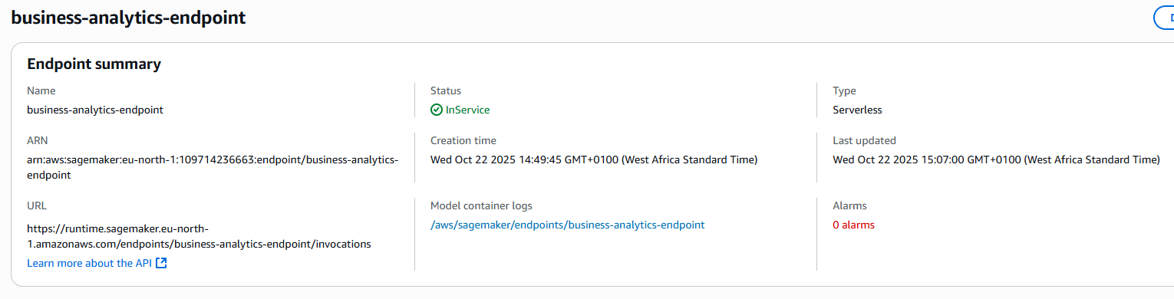

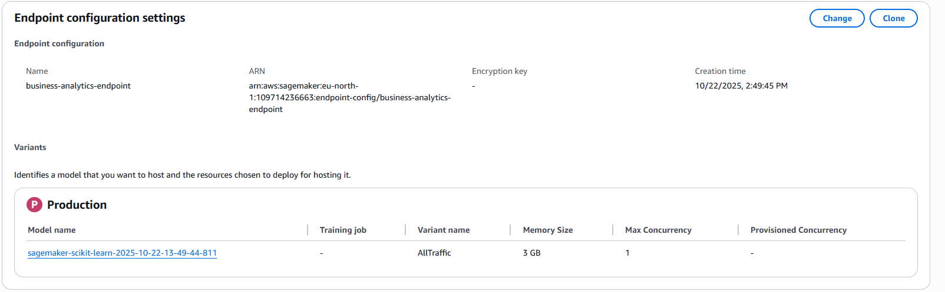

IAM Role

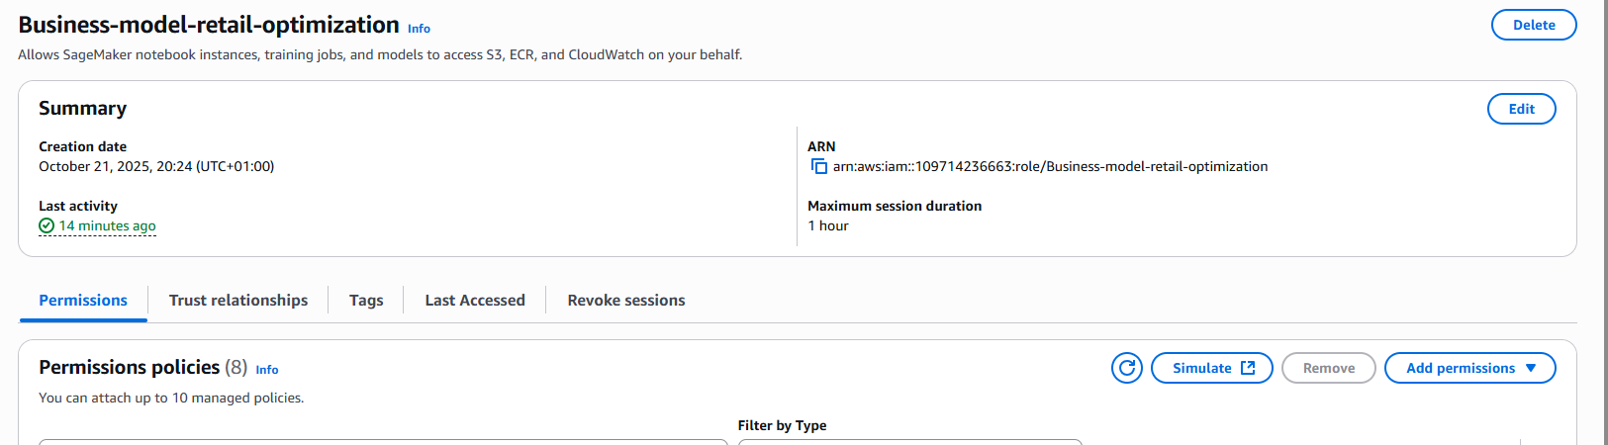

S3 Bucket

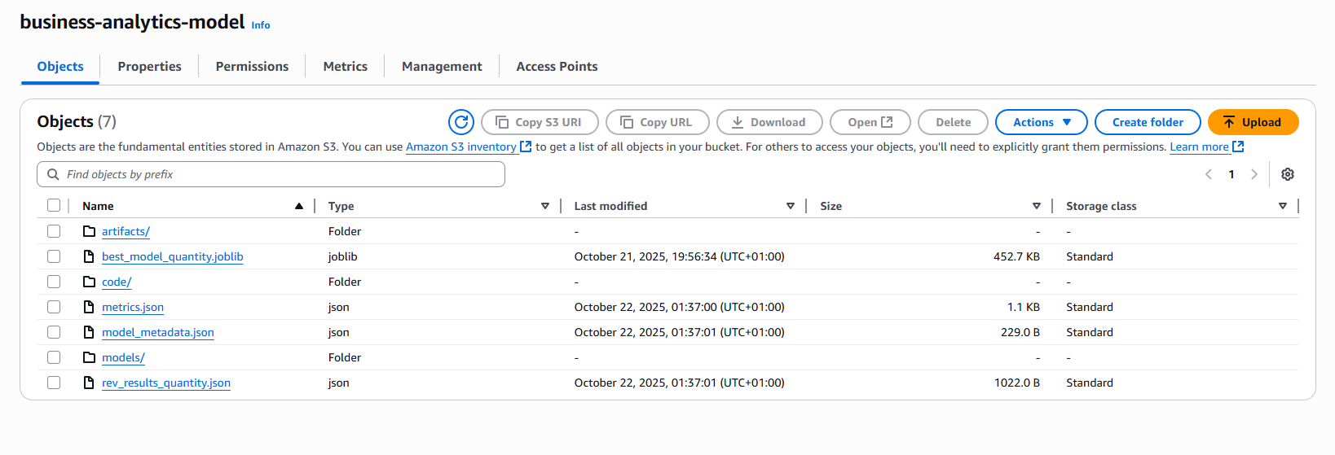

**SagerMaker Node Book Instance**

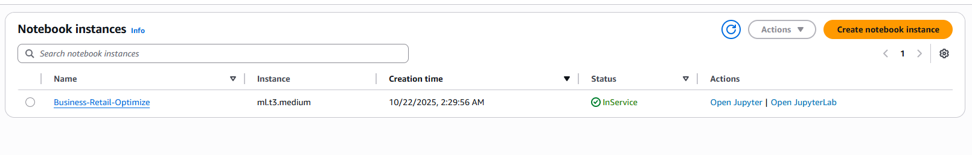

**Notebook Instance showing linked Github repository**

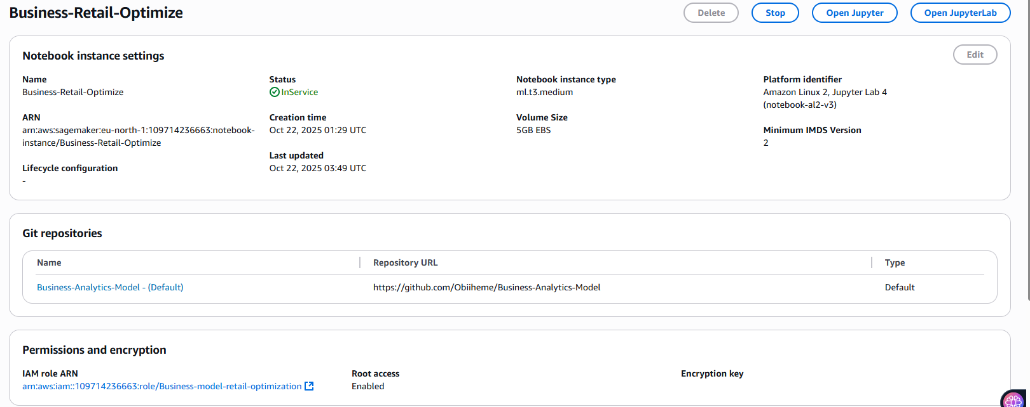

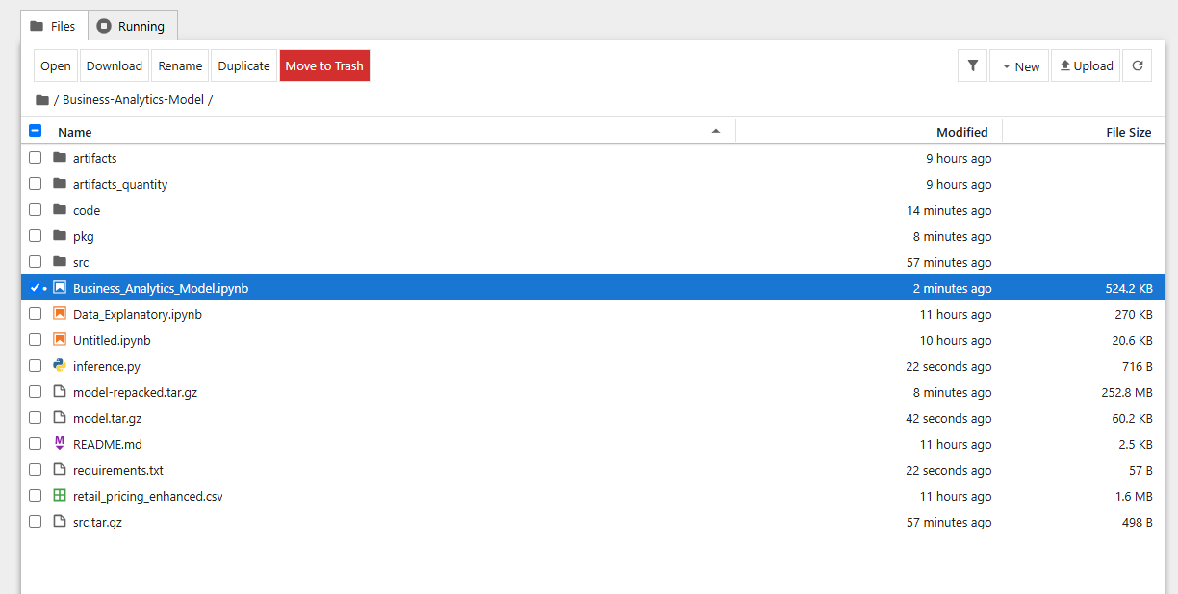

Final Code block that worked.

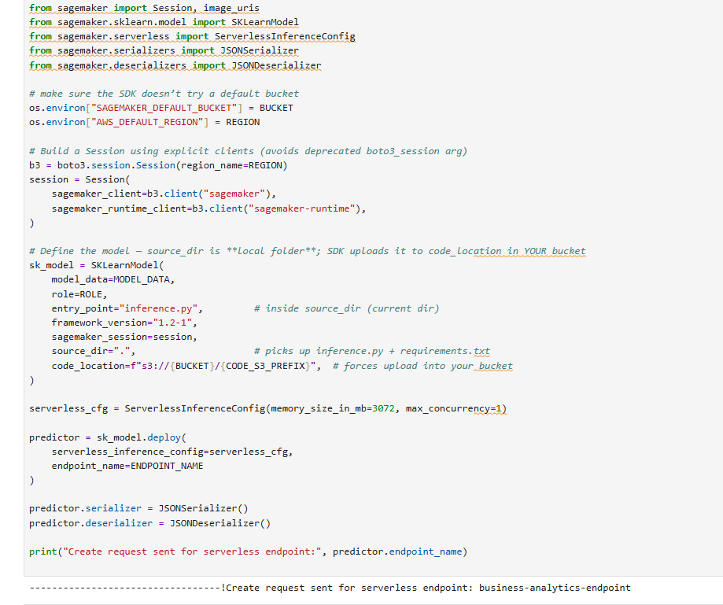

Smoke test was not successful because the endpoint was a serverless deployment with minimum of 3072MB capacity

